**NETD2202 – Lab 3**

(*Sonadi Kannangara #100778336*)

* Desk-check

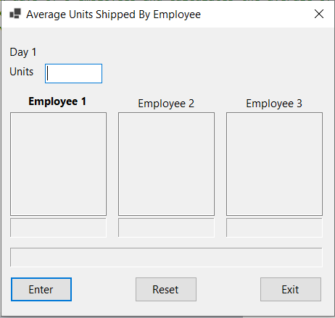

|  |  |  |
| --- | --- | --- |
| Average Units Shipped by Employee | | |
| Day  Units | | |
| Employee 1 | Employee 2 | Employee 3 |
| 2 | 9 | 3 |
| 3 | 8 | 4 |
| 4 | 7 | 5 |
| 5 | 6 | 6 |
| 6 | 5 | 7 |
| 7 | 4 | 8 |
| 9 | 3 | 9 |
| Average: 5.14 | Average: 6.00 | Average: 6.00 |
| Average Per Day: 5.71 | | |

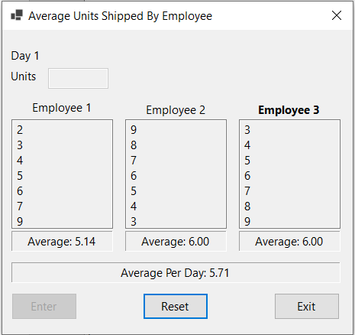

|  |  |  |
| --- | --- | --- |
| Average Units Shipped by Employee | | |
| Day  Units | | |
| Employee 1 | Employee 2 | Employee 3 |
| 23 | 88 | 29 |
| 34 | 77 | 38 |
| 45 | 66 | 47 |
| 56 | 55 | 56 |
| 67 | 44 | 65 |
| 78 | 33 | 74 |
| 89 | 22 | 83 |
| Average: 56.00 | Average: 55.00 | Average: 56.00 |
| Average Per Day: 55.67 | | |

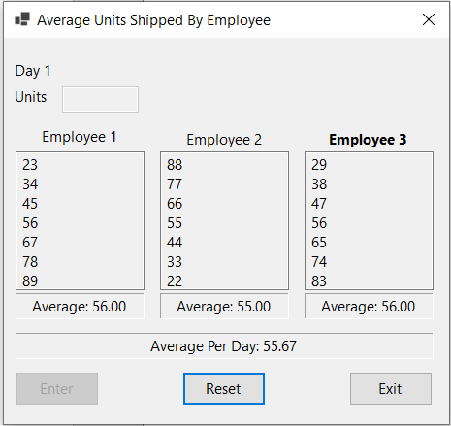

|  |  |  |
| --- | --- | --- |
| Average Units Shipped by Employee | | |
| Day 6  Units 5001 | | |
| Employee 1 | Employee 2 | Employee 3 |
| 67 |  |  |
| 56 |  |  |
| 45 |  |  |
| 5000 |  |  |
| 0 |  |  |
|  |  |  |
|  |  |  |
| Average: | Average: | Average: |
|  | | |

|  |
| --- |
| Enter a value between 0 and 5000. Invalid Valid! |

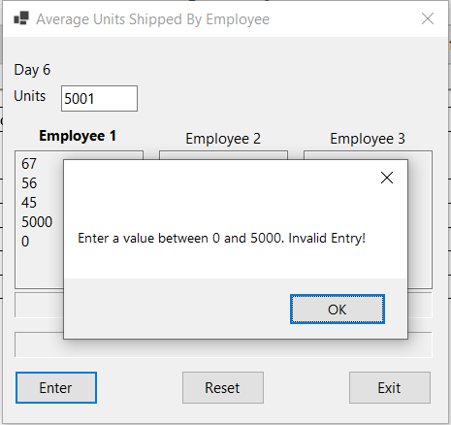

|  |  |  |
| --- | --- | --- |
| Average Units Shipped by Employee | | |
| Day 4  Units ten | | |
| Employee 1 | Employee 2 | Employee 3 |
| 30 |  |  |
| 45 |  |  |
| 67 |  |  |
|  |  |  |
|  |  |  |
|  |  |  |
|  |  |  |
| Average: | Average: | Average: |
|  | | |

|  |
| --- |
| Entry must be a numeric value. Invalid Entry! |

